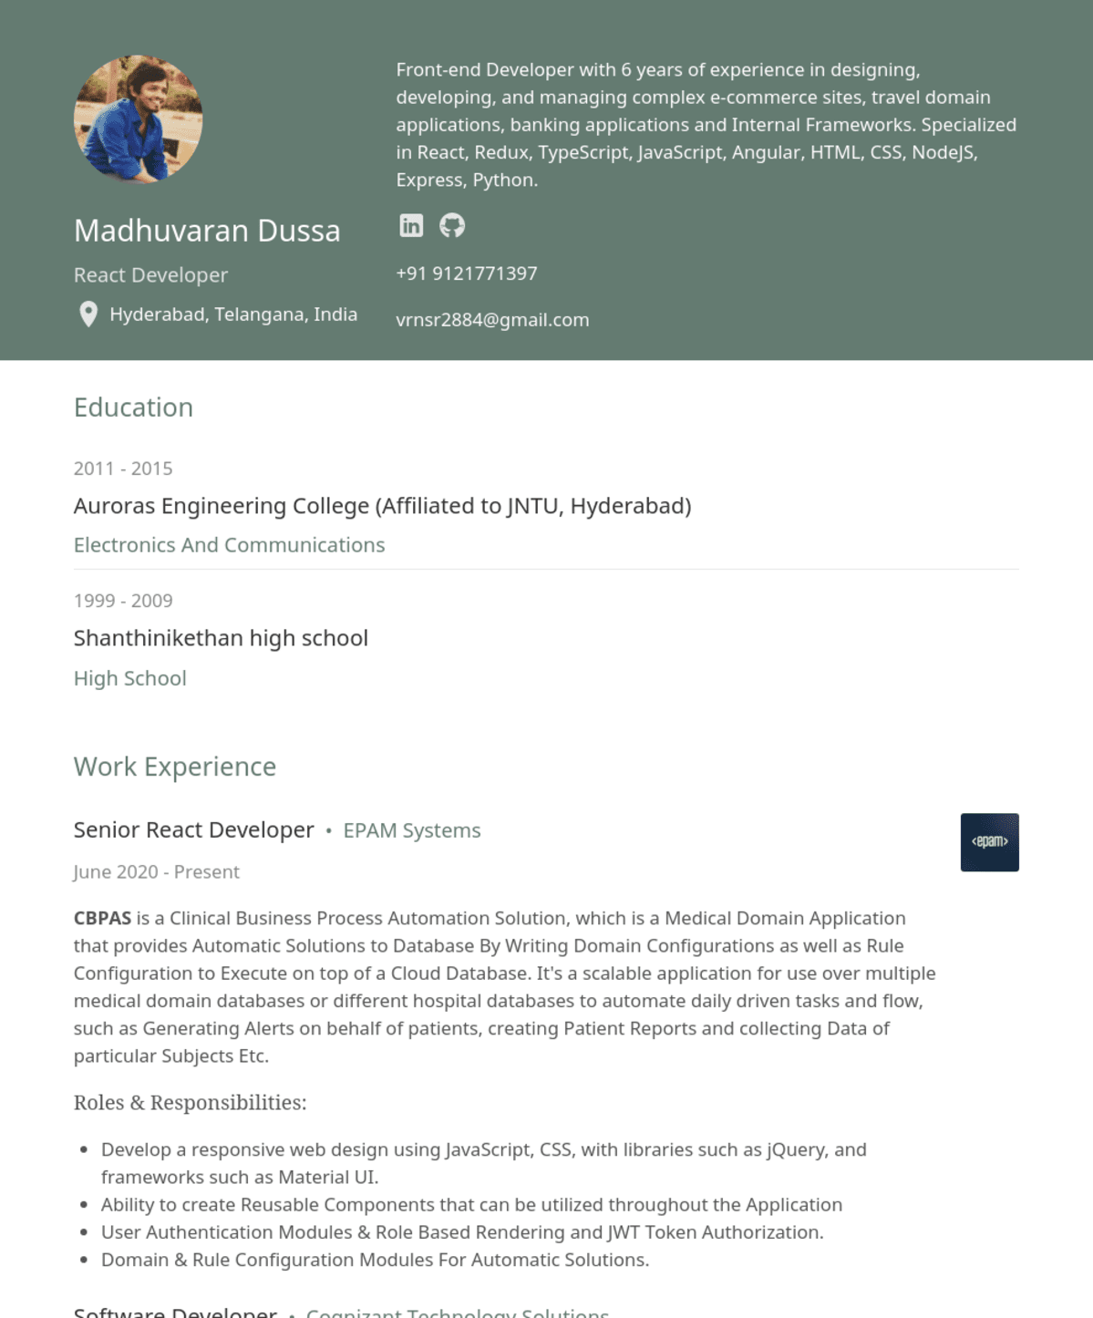
Front-end Developer with 6 years of experience in designing,
developing, and managing complex e-commerce sites, travel domain applications, banking applications and Internal Frameworks. Specialized in React, Redux, TypeScript, JavaScript, Angular, HTML, CSS, NodeJS, Express, Python.
Madhuvaran Dussa
React Developer
Hyderabad, Telangana, India
+91 9121771397
vrnsr2884@gmail.com
Education
2011-2015
Auroras Engineering College (Affiliated to JNTU, Hyderabad)
Electronics And Communications
1999-2009
Shanthinikethan high school
High School
Work Experience
Senior React Developer EPAM Systems
June 2020 - Present
CBPAS is a Clinical Business Process Automation Solution, which is a Medical Domain Application that provides Automatic Solutions to Database By Writing Domain Configurations as well as Rule Configuration to Execute on top of a Cloud Database. It's a scalable application for use over multiple medical domain databases or different hospital databases to automate daily driven tasks and flow, such as Generating Alerts on behalf of patients, creating Patient Reports and collecting Data of particular Subjects Etc.
Roles & Responsibilities:
• Develop a responsive web design using JavaScript, CSS, with libraries such as jQuery, and frameworks such as Material UI.
Ability to create Reusable Components that can be utilized throughout the Application • User Authentication Modules & Role Based Rendering and JWT Token Authorization.
• Domain & Rule Configuration Modules For Automatic Solutions.
Software Developer
Cognizant Technology Solutions
<epam>

